Equivalence Partitioning (EP)

Definition
# Source: AI Source: Provided by: [Data Path: Persons Table -> ID Column: 1, Name_En Column: Motasem Essam] -> From: [Chatgpt (GPT‑5 Mini)] on [8/24/2025]
Equivalence Partitioning (EP) is a black-box test design technique where input data is divided into partitions (classes) that are expected to be treated the same by the system.
You then pick one representative value from each partition to test, instead of testing every possible value.
Goal: Reduce the total number of test cases while still covering a wide range of scenarios.

Why use EP?
# Source: AI Source: Provided by: [Data Path: Persons Table -> ID Column: 1, Name_En Column: Motasem Essam] -> From: [Chatgpt (GPT‑5 Mini)] on [8/24/2025]
- Saves time (tests fewer values).
- Ensures coverage of valid and invalid inputs.
- Detects classes of defects that occur for a whole range of values.

Valid and Invalid Partitions
# Source: AI Source: Provided by: [Data Path: Persons Table -> ID Column: 1, Name_En Column: Motasem Essam] -> From: [Chatgpt (GPT‑5 Mini)] on [8/24/2025]
Here’s a clear explanation of valid and invalid partitions in Equivalence Partitioning (EP):

Equivalence Partitioning (EP) Recap
- EP divides input (or output) data into partitions, where all values in a partition are expected to be treated similarly by the system.
- Instead of testing every possible value, you test one representative value from each partition.

1. Valid Partitions
- Definition: A partition that contains values considered correct or acceptable according to the system requirements or specifications.
- Purpose: Ensure the system processes correct inputs correctly.
- Example:
  - Input: Age of a person (1–120)
  - Valid partition: 18–65 (for adult eligibility)
  - Test representative value: 30

2. Invalid Partitions
- Definition: A partition that contains values considered incorrect, unacceptable, or out-of-spec according to the system requirements.
- Purpose: Ensure the system handles incorrect inputs gracefully, e.g., by showing an error message.
- Example:
  - Input: Age of a person (1–120)
  - Invalid partitions: < 1, > 120, or negative values
  - Test representative values: 0, -5, 130

Key Points
- Each partition should be non-empty and mutually exclusive.
- Testing one value from each partition is sufficient to assume the system behaves the same for all other values in that partition.
- Valid and invalid partitions help cover both positive and negative scenarios.

How It Works
# Source: AI Source: Provided by: [Data Path: Persons Table -> ID Column: 1, Name_En Column: Motasem Essam] -> From: [Chatgpt (GPT‑5 Mini)] on [8/24/2025]
- Identify input conditions from the requirements.
- Divide into partitions where all values in the partition should behave the same.
- Mark partitions as valid or invalid.
- Choose one value from each partition for testing.

Example – Banking App PIN Entry
# Source: AI Source: Provided by: [Data Path: Persons Table -> ID Column: 1, Name_En Column: Motasem Essam] -> From: [Chatgpt (GPT‑5 Mini)] on [8/24/2025]
Rule: PIN must be a 4-digit number (1000–9999).
- Invalid Partition 1: Numbers less than 1000 (e.g., 999).
- Valid Partition: 1000 to 9999 (e.g., 4567).
- Invalid Partition 2: Numbers greater than 9999 (e.g., 12345).
Test Cases using EP:
- 999 → Invalid
- 4567 → Valid
- 12345 → Invalid

Example – Postal Rate Problem (from your earlier question)
# Source: AI Source: Provided by: [Data Path: Persons Table -> ID Column: 1, Name_En Column: Motasem Essam] -> From: [Chatgpt (GPT‑5 Mini)] on [8/24/2025]
Rule:
- 0–10g → 25p
- 11–50g → 35p
- 51–75g → 45p
- 76–100g → 55p
Partitions (Valid ranges):
- 0–10g (e.g., 8g)
- 11–50g (e.g., 42g)
- 51–75g (e.g., 65g)
- 76–100g (e.g., 82g)
Invalid partitions:
- Less than 0g
- Greater than 100g

Coverage
# Source: AI Source: Provided by: [Data Path: Persons Table -> ID Column: 1, Name_En Column: Motasem Essam] -> From: [Chatgpt (GPT‑5 Mini)] on [8/24/2025]
In Equivalence Partitioning (EP),
📌 Definition of Coverage
- The coverage items are the equivalence partitions (valid and invalid).
- Coverage = the proportion of identified partitions that are exercised by at least one test case.
📊 Formula
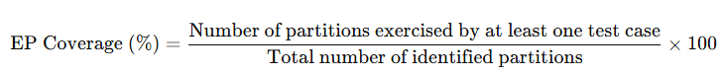
EP Coverage (%)=Number of partitions exercised by at least one test caseTotal number of identified partitions×100\text{EP Coverage (\%)} = \frac{\text{Number of partitions exercised by at least one test case}}{\text{Total number of identified partitions}} \times 100

✅ Example
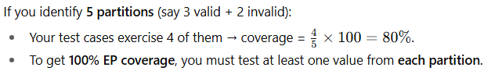
If you identify 5 partitions (say 3 valid + 2 invalid):
- Your test cases exercise 4 of them → coverage = 45×100=80%\frac{4}{5} \times 100 = 80\%.
- To get 100% EP coverage, you must test at least one value from each partition.

👉 So, in short: EP coverage measures how many partitions you actually tested compared to how many you identified.

Got it 👍 Let’s walk through a practical example of Equivalence Partitioning (EP) coverage:

Example: Age Input Field
Suppose a system accepts an age input from 18 to 60 (inclusive).
Step 1: Identify partitions
- Valid partition: 18 → 60
- Invalid partition 1: less than 18
- Invalid partition 2: greater than 60
Step 2: Choose representative test values
- From valid partition: pick 25
- From invalid partition 1: pick 10
- From invalid partition 2: pick 70
Step 3: Define coverage
Coverage items = all identified partitions (valid + invalid).
To achieve 100% EP coverage:
- Test at least one value per partition.
Here:
- 25 → covers valid partition
- 10 → covers invalid partition 1
- 70 → covers invalid partition 2
✅ Coverage achieved: 3/3 partitions = 100%

👉 The rule is simple: each identified partition must be exercised by at least one test case.

Each Choice Coverage
# Source: AI Source: Provided by: [Data Path: Persons Table -> ID Column: 1, Name_En Column: Motasem Essam] -> From: [Chatgpt (GPT‑5 Mini)] on [8/24/2025]
Here’s a clear explanation of Each Choice Coverage in Equivalence Partitioning (EP):

Equivalence Partitioning (EP) Recap
- EP divides input data into equivalence partitions, where all values in a partition are expected to be treated similarly by the system.
- You test one representative value from each partition instead of every possible value.

Each Choice Coverage
- Definition: A coverage criterion used when a test item has multiple sets of partitions (e.g., multiple input parameters).
- Rule: Each partition in every set of partitions must be exercised at least once by a test case.
- Goal: Ensure all partitions are represented in the test cases.
- Note:
  - It does not require testing all possible combinations of partitions.
  - It is simpler than full combinatorial testing.

Example
Suppose a form has two input fields:
- Age:
  - Partition 1: 18–65 (valid)
  - Partition 2: <18 or >65 (invalid)
- Membership Type:
  - Partition 1: Standard
  - Partition 2: Premium
Each Choice Coverage Test Cases:
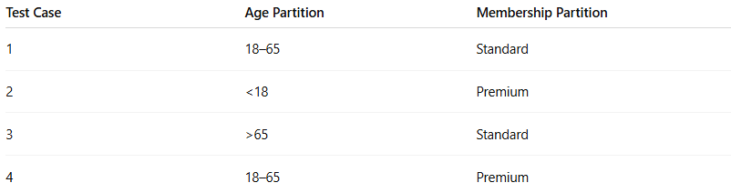
Test Case | Age Partition | Membership Partition
1 | 18–65 | Standard
2 | <18 | Premium
3 | >65 | Standard
4 | 18–65 | Premium
✅ Each partition is used at least once, but not all combinations are covered exhaustively.

Key Point:
- Each Choice Coverage ensures all partitions are tested, but doesn’t test every combination, which keeps the number of test cases manageable.

